

**FACULTY OF ENGINEERING, SCIENCE AND TECHNOLOGY**

**DEPARTMENT OF COMPUTER SCIENCE**

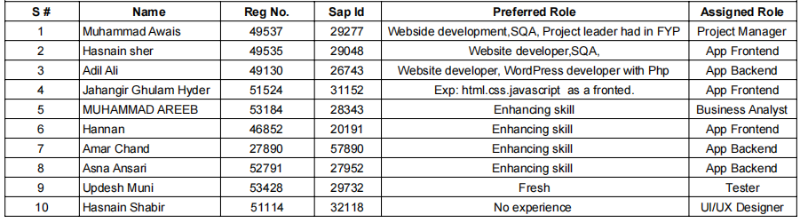

**ROJECT:**

**Shopkeeper Inventory and POS App**

**COORDINATOR NAME:**

**Daniyal Nawaz**

**Jan/26/ 2024**

**ABSTRACT**

The Shopkeeper Inventory and POS App redefines how shopkeepers manage inventory and conduct sales, addressing challenges in a user-friendly way. This mobile solution focuses on improving accuracy, simplifying checkout, and enhancing efficiency. Key features include inventory management, secure POS, user authentication, reporting, and an intuitive interface. The app's three-tier architecture uses React Native, Node.js, Express.js, and MongoDB for responsiveness and cross-platform functionality. Agile development, tackling challenges in payment integration and real-time updates, ensures adaptability. Future plans involve customer features, e-commerce integration, and AI-driven inventory forecasting. In essence, it's a transformation tool for efficient retail management.

Project Coordinator:Daniyal Nawaz

Date: 26-01-2024

**ACKNOWLEDGEMENT**

We extend our heartfelt gratitude to [Iqra University] for their unwavering support and resources, making the Shopkeeper Inventory and POS App project possible.

A special thank you to our dedicated project team, whose collective efforts and skills were pivotal in bringing this application to fruition.

Appreciation is also extended to [External Partners/Advisors] for their valuable insights, contributing significantly to the project's success.

Our sincere thanks go out to the community of beta testers and early users for their feedback, instrumental in refining the app.

Lastly, we express gratitude to our families and friends for their understanding and encouragement throughout the project.

This project is a testament to the strength of collaboration and shared dedication. Thank you to all who played a role in this journey.

**Executive Project Summary**

The Shopkeeper Inventory and POS App is a revolutionary mobile application designed to address the challenges faced by shopkeepers in managing their product inventory and facilitating seamless point-of-sale transactions. By offering features such as real-time inventory tracking, efficient checkout processes, and user-friendly interfaces, the app aims to streamline operations and enhance the overall shopping experience for both shopkeepers and customers.

**Introduction**

In the retail industry, shopkeepers often encounter difficulties in maintaining accurate inventory records and managing the checkout process effectively. The Shopkeeper Inventory and POS App aims to alleviate these challenges by providing a comprehensive solution in the form of a mobile application. This app empowers shopkeepers to take control of their inventory and simplifies the point-of-sale process, ultimately contributing to increased efficiency and customer satisfaction.

**Objectives**

The primary objectives of the Shopkeeper Inventory and POS App project include:

- Improving inventory management accuracy.

- Streamlining the point-of-sale process for faster transactions.

- Providing a user-friendly interface for easy navigation.

- Enhancing the overall efficiency of shopkeepers' operations.

**Features and Functionality**

**Inventory Management:**

Product Management

- Add, delete, and modify products with detailed information.

- Categorize products based on attributes such as type, brand, and price range.

- Set and track reorder levels to prevent stock-outs.

Real-time Tracking

- Monitor stock levels in real-time to avoid overstocking or stock outs.

- Receive alerts for low stock levels or expiring products.

**Point of Sale (POS):**

**Secure Checkout**

- Implement a secure and efficient checkout process.

- Integrate with popular payment gateways to support various payment methods.

- Generate digital receipts for transactions.

**User Authentication**

- Implement a secure login system for shopkeepers.

- Utilize role-based access control to manage permissions.

**Reporting and Analytics:**

Sales Reports

- Generate detailed sales reports, including revenue and quantity sold.

- Analyze sales data to identify trends and popular products.

**Inventory Status Reports**

- View comprehensive inventory status reports, including stock levels and product details.

**User Interface:**

Intuitive Design

- Design an intuitive and user-friendly interface for easy navigation.

- Ensure responsiveness for various devices, including smartphones and tablets.

**System Architecture**

**The Shopkeeper Inventory and POS App follows a three-tier architecture:**

**Presentation Layer:**

- Mobile application interface for shopkeepers.

- Responsive design for optimal user experience.

**Application Layer:**

- Back end server handling business logic.

- API integration for external services.

Data Layer:

- Database for storing product information, inventory data, and user details.

**Technologies Used**

The technologies utilized in the development of the Shopkeeper Inventory and POS App include:

**Front-end:**

- React Native for cross-platform mobile application development.

- Responsive design principles for a seamless user experience.

- **Back-end**

- Node.js,java for server-side development.

- Express.js for building RESTful APIs.

**Database:**

MongoDB for storing product information and inventory data.

**Authentication:**

JWT (JSON Web Token) for secure user authentication.

**Development Process**

The project followed an Agile development methodology, comprising the following phases:

**Planning:**

- Defined project goals and requirements.

- Created user stories and prioritized features.

**Design:**

- Developed wire frames and UI/UX designs.

- Defined the database schema.

**Implementation:**

- Used an iterative approach to develop and test features.

- Regular sprint reviews and adjustments.

**Testing:**

- Conducted unit testing and integration testing.

- Gathered feedback from beta testing with shopkeepers.

**Deployment:**

- Deployed the application to app stores (iOS App Store and Google Play).

- Monitored post-deployment for any issues.

**Challenges and Solutions**

**Challenges:**

**Integration with Payment Gateways:**

- Ensuring secure and seamless integration with multiple payment gateways.]

**Real-time Inventory Updates:**

- Achieving real-time updates for inventory levels without affecting performance.

Solutions:

**Payment Gateway Integration:**

Collaborated with payment gateway providers for comprehensive integration testing.

mplemented secure encryption for transaction data.

**Real-time Inventory Updates:**

Utilized Web Socket technology for real-time communication between the app and server.Implemented background processes for updating inventory asynchronously.

**Future Enhancements**

Future enhancements for the Shopkeeper Inventory and POS App include:

- Customer-Facing Features:

- Loyalty programs for customers.

- Digital receipts sent to customers via email or SMS.

- Integration with E-commerce Platforms:

- Integrating the app with popular e-commerce platforms for a seamless online and offline shopping experience.

- AI-powered Inventory Forecasting:

- Implementing machine learning algorithms for predictive inventory forecasting.

**Conclusion**

The Shopkeeper Inventory and POS App project successfully addresses the challenges faced by shopkeepers in managing their inventory and processing transactions. By providing a user-friendly and efficient solution, the app contributes to improved operational efficiency, increased customer satisfaction, and a streamlined retail experience.

**References**

The development of the Shopkeeper Inventory and POS App made use of various frameworks, libraries, and tools. References include documentation for React Native, Node.js, Express.js, MongoDB, and other technologies used in the project.

**Appendices**

Include any additional information, charts, or data supporting the content of the report. This may include user feedback, beta testing results, or additional technical details.

**User Flow Er Diagram**

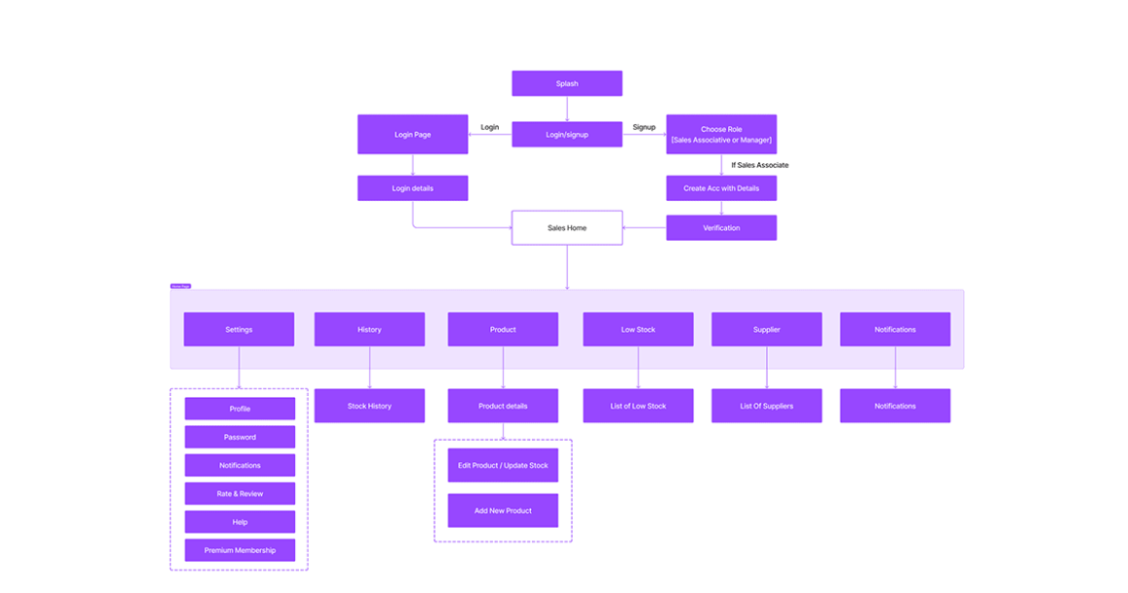

**Controller Flow Er Diagram**

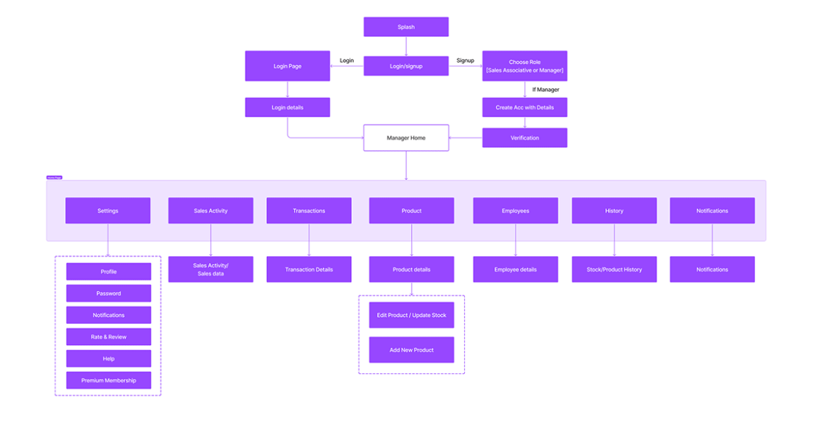

**UI/UX Design**

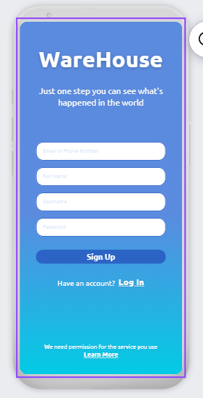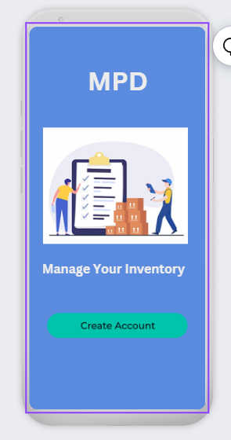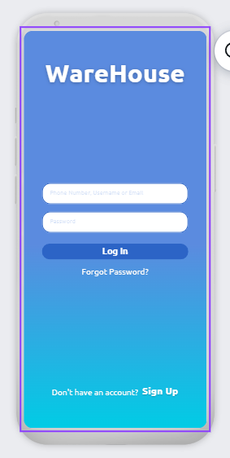

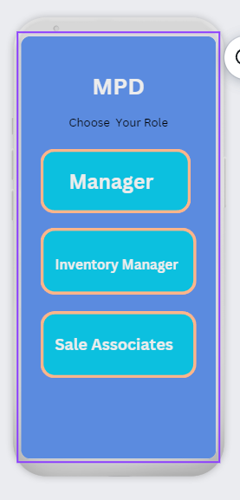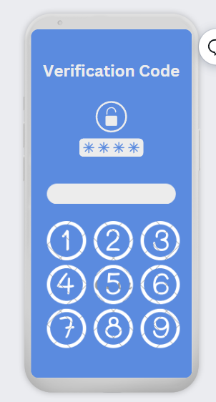

End!